Annual Report 2016
Kulea Childcare Villages, Inc.
We are on a mission to help each Kulea child to reach his or her full potential. Loving adults speak into children’s lives on a daily basis in an environment saturated with grace and love.
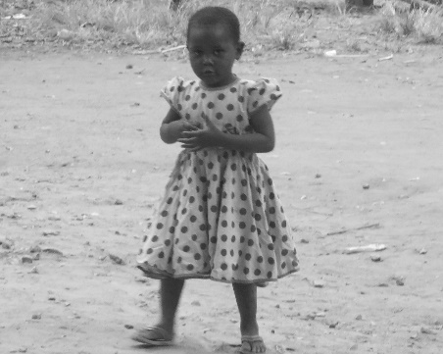
In 2016 we were busy providing the necessary sustained attention to make real differences in the lives of our children.
Total Care Program - Kulea Home
--We rescued an abandoned child – tiny Sarah (pictured)
--12 children were loved on, fed, clothed, educated & discipled.
--12,500 meals were served in this home in 2016! Bless the cooks!

Child Assistance Program
12 children in Kenya & 6 children in Tanzania were in school thanks to Kulea sponsors!
Feeding & Preschool Programs
92,000 meals for vulnerable preschool children and widows were served (45 children/widows - Tanzania site & 110 children/widows at our Kenya site).

Community Support
A Kulea volunteer spent two months in Kenya, providing school supplies & volunteering in 3 community schools. He taught various subjects and got to know the students.
Ubazi Village
We provided clean water to 21 needy women. Further development of this property and fundraising for development have been put on hold until we have a title to the land from the Tanzania government (applied for in 2011).

Kulea governing boards in East Africa
Tanzania: In mid-2016, the USA Board Chairman and the Executive Director traveled to Tanzania and had good meetings with the TZ Board of Directors.
Kenya: During that trip, our ED also traveled to Kenya to check on our first long-term volunteer, make home visits to all Kulea children, and encourage our staff. She was amazed at Manna Church’s new worship center. Members are daily, sacrificially giving and praying for funding of a new preschool building, required by the government.
Prayer Requests
  - Safety for our Kenyan pastor, staff and volunteers during new elections
- Our continued care for orphans and vulnerable children
- Additional partnerships with USA churches
- Funding of construction projects & on-time payments from child sponsors

